Contents
(1) Conceptual Design 1
1.1 High-level physical view 1
1.2 Physical elements and their arrangements 1
(2) Detailed Design 2
2.1 Preliminary Weight Estimation 2
2.2 Thrust Requirements Estimation 2
2.3 Propulsion System Selection 2
2.3.1 Motor 3
2.3.2 ESC (Electronic Speed Controller) 3
2.3.3 Propeller 4
2.4 UAS Sizing 4
2.4.1 Wheelbase 4
2.4.2 Rotor Arm Length 4
2.4.3 Hub Size 5
2.4.4 Propeller Clearance 5
2.4.5 Landing Gear Dimensions 5
2.5 UAS Performance Estimation 5
2.5.1 Power Requirements 5
2.5.2 Battery Selection 6
2.5.3 Endurance Estimation 6
2.6 Material Selection 6
2.7 Subsystem Selection 7
2.7.1 Communication System 7
2.7.2 Control & Navigation System 8
2.7.3 Avionics and sensors 12
2.8 Center of Gravity (C.G.) Estimation & Stability Analysis 12
2.9 Preliminary CAD Model 14
2.10 Computational Analysis 15
2.11 Optimized Final Design 18
2.11.1 Final CAD model 18
2.11.2 Final 2D drafting 19
2.11.3 Updated C.G. analysis 19
2.12 Detailed Weight Breakdown & C.G. Analysis 20
2.12 UAS Performance Recalculation 22
2.12.1 Thrust-to-weight ratio 22
2.12.2 Power requirements for the mission 22
2.12.3 Endurance Calculation 23
(3) Final UAS Specifications and Bill of Materials (BoM) 23
(4) Methodology for Autonomous Operations 24
4.1 Detailed Methodology for Implementing Autonomous Flight 24
4.2 Surveying Method and Autonomous Data Collection 24
4.3 Techniques for Autonomous Object or Target Identification 24
4.4 Disaster Management and Response 25
(5) Summary of Innovations 26
5.1 Payload box with Gyroscope 26
(6) References 28

(1) Conceptual Design

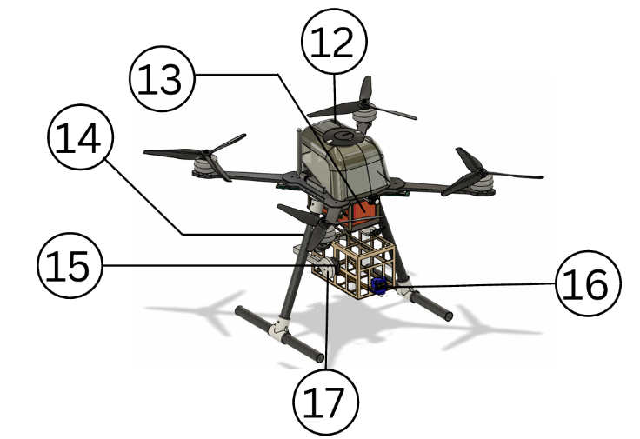
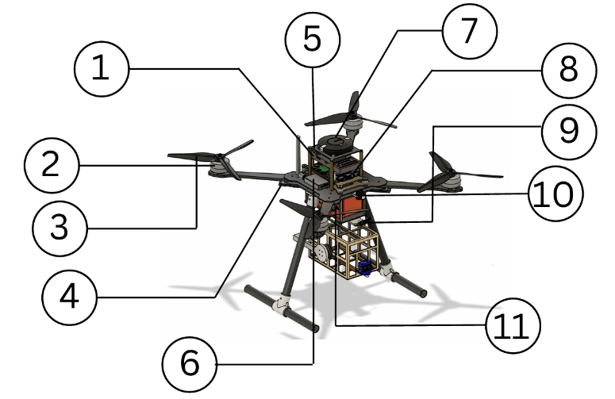
1.1 High-level physical view

1.2 Physical elements and their arrangements
S. no. | Description
1. | Flight Controller Pixhawk Cube Orange+
2. | Tarot 4008 330KV Motor
3. | 3K Carbon Fiber Propeller 1755
4. | Cyclone 45A ESC
5. | T12 TX RX
6. | CUAV Neo 3
7. | Flight Computer Raspberry Pi 5 4GB
8. | 8400mAh 2*6S Battery
9. | RunCam Phoenix 2 SP V3
10. | Holybro PM06 V2 Power Module
11. | GEPRC MATEN 5.8G 3W VTX PRO

(2) Detailed Design

2.1 Preliminary Weight Estimation
In this section, we present the method we used for the preliminary weight estimation of our UAV. We achieved this by analyzing the weight of each individual component in our design and cross-verifying these values with reference datasets. This approach allowed us to ensure accuracy and reliability in our total weight calculation, which is critical for performance, flight time, and payload capacity planning.
Given below are the preliminary weight estimation of our UAV:
Components | No. of Units | Unit Weight  (in grams) | Total Weight  (in grams)
Flight Controller | 1 | 33g | 73g
BLDC Motor | 4 | 85g | 340g
Propeller | 4 | 36g | 144g
GPS | 1 | 33g | 55g
Battery | 2 | 850g | 1700g
ESC | 4 | 6g | 24g
Camera | 1 | 7.5g | 7.5g
Flight Computer | 1 | 50g | 50g
 | Total Weight |  | ~

2.2 Thrust Requirements Estimation
To ensure stable lift-off, efficient hovering, and reliable mission execution, we analyzed the thrust-to-weight ratio of our UAV. The system was evaluated based on its structural weight, payload, and propulsion capabilities.
Parameter | Value
Takeoff Weight | ~2100 g
Thrust per Motor | ~3250g
Total Thrust | ~13000 g
Thrust-to-Weight Ratio | ~6.2:1

2.3 Propulsion System Selection
The propulsion system is one of the most critical subsystems in a drone, directly influencing its performance, efficiency, and mission capability. Selecting the appropriate propulsion system involves careful consideration of the drone's intended application, weight, endurance, and operating conditions.
Given below are the key components of the propulsion system:

2.3.1 Motor
The propulsion system design began with the selection of a motor suitable for a multi-rotor UAV intended for disaster management operations. After evaluating various high-power propulsion options, the Tarot 4008 330KV brushless motor was selected for its high torque output, reliability, and efficient performance with large-diameter propellers. The low-KV configuration enables stable lift at lower rotational speeds, improving flight efficiency, endurance, and control, which are essential for precise manoeuvring and payload delivery in emergency response missions
Tarot 4008 (330 KV) Specification:
Specification
Max Thrust | 3.5kg
Weight | 85g
Maximum current | 30A
Maximum power | 497W
Recommended Battery | 6S(LiPo)
2D Drawing of Motor
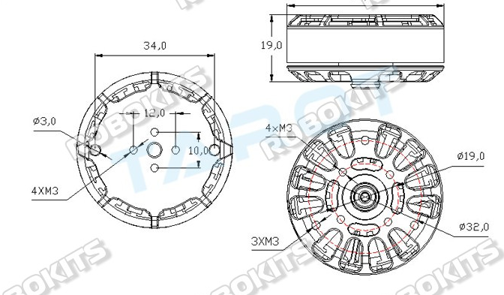

2.3.2 ESC (Electronic Speed Controller)
The Cyclone 45A BLHeli-S ESC is a high-performance ESC for multirotor drones, featuring a 6-layer, 3-oz gold-plated PCB for better current handling, heat dissipation, and durability. Its optimized layout ensures strong anti-jamming and stable operation. Supporting DShot 150/300/600, along with Damped Light and regenerative braking, it provides smooth throttle response, fast motor deceleration, and low noise, while an integrated RGB LED improves night-flight visibility.
ESC Specification:
Specification
Output Voltage | Support 2-6S power supply
Supported protocols | dshot 125/300/600
Power Cord lenght | 18AWG 90mm
Working Current | 35A
Signal line length | 150 mm

2.3.3 Propeller
The Carbon Fiber 1755 Propeller (17×5.5) is a lightweight, high-strength propeller designed for high-performance drones and UAVs. It delivers strong thrust, high efficiency, and stable flight with reduced vibration and quick throttle response. Its aerodynamically optimized design and easy, quick installation make it ideal for DIY, multirotor, and professional UAV applications.
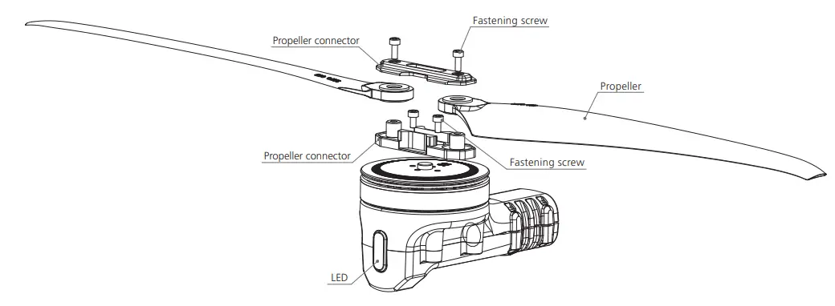
2D Drawing of Propeller

2.4 UAS Sizing
UAS sizing involves selecting the right drone dimensions and components based on its mission and payload to ensure optimal performance, stability, and flight time.

2.4.1 Wheelbase
The wheelbase is the distance between opposite motors and defines the drone's overall size. For our UAV, a ~1180 mm wheelbase offers a balanced platform for stable flight and efficient thrust.
Drawing for Wheelbase

2.4.2 Rotor Arm Length
The rotor arm length of our UAV is ~190 mm, providing the necessary clearance for optimal propeller size and efficient thrust generation.
Drawing for Rotor Arm Length

2.4.3 Hub Size
The drone’s hub size, measured diagonally between motor mounts, is about ~15.5 mm by ~20 mm, ensuring secure motor fit and stable flight.
Drawing for Hub Size

2.4.4 Propeller Clearance
Propeller clearance is the minimum space between propellers and the drone frame or components to prevent obstruction. Our drone has ~45 mm clearance from body and ~121 mm between propellers for safe, efficient operation.
Drawing for Propeller Clearance

2.4.5 Landing Gear Dimensions
For our drone, the Ground Clearence is ~193 mm, Landing Gear Length is ~213 mm providing sufficient clearance from the ground.
Drawing for Landing Gear Dimensions

2.5 UAS Performance Estimation
UAS Performance Estimation analyzes power, battery, and flight time to ensure efficient, safe operation. With our chosen battery and motors, the UAV offers stable performance and adequate flight time for its tasks.

2.5.1 Power Requirements
S. no. | Components | Name | Operating Voltage  (V) | Operating Current (A) | Power Consumption (w)
1 | Flight Controller |  | 4.1V to 5.7V | 2.5A | 14W
2 | BLDC Motors (x4) |  | 24V | 20.3A | 495.2W
3 | ESC |  | 22.2V | 45A | -
4 | Camera |  | DC 5-36V | 120 mA | 0.6 W
5 | VTX |  | 7-36V | 800mA(12v) | 10W
6 | GPS |  | 4.7 – 5.1 V | 1A | 5W
7 | Flight Computer |  | 5.1V DC | 5A | 9.8W
 | Total…………...

2.5.2 Battery Selection
Battery selection is crucial for a drone’s flight time, efficiency, and performance.
We chose a 25200mAh 4S (25V) 6*2LiPo battery, providing enough voltage and steady current for our motor and ESC.
Specification
Model | 6S
Capacity | 25200mAh
C Rating | 11C
Max. Continuous Discharge
Max. Voltage
Normal Voltage

2.5.3 Endurance Estimation
UAV endurance is the total flight time on one battery charge, affected by drone size, weight, payload, and power management.
The drone draws about 27A (shown on Mission Planner) with a 2kg weight. To achieve a minimum 10-minute flight time, this battery balances weight and capacity, ensuring reliable endurance for aerial tasks.

The Estimated calculation for endurance is hereby: -
Endurance (hrs.) = Battery Capacity (Ah) / Current Drawn (A)
Endurance (min.) = (5.2(Ah) / 27(A)) * 60 = 11.5 min

2.6 Material Selection
Material selection focuses on achieving a balance between strength, weight, and durability. PETG, PLA+, and ABS are used for structural components due to their good mechanical properties and ease of fabrication. Carbon Fiber and PLA-CF are selected for high-strength, load-bearing parts, while TPU is used for flexible and vibration-damping components to improve impact resistance and protect onboard electronics.

2.7 Subsystem Selection

2.7.1 Communication System
Communication System in a drone enables data exchange between the UAV and ground control for remote control and real-time monitoring.
(I) Skydroid T12(Transmitter)
A handheld device used by the pilot to send control signals (throttle, pitch, roll, yaw) to the drone.
We are using the Skydroid T12 transmitter, a versatile and feature-rich radio controller that supports multiple protocols, offers customizable controls, and ensures reliable long-range communication ideal for professional drone operations.
Specification
Transmission Frequency | 2.400 GHz – 2.4833 GHz
Working Current | 170 mA
Working Voltage | 3.7 V
Channels | Up to 12 (depending on the receiver)
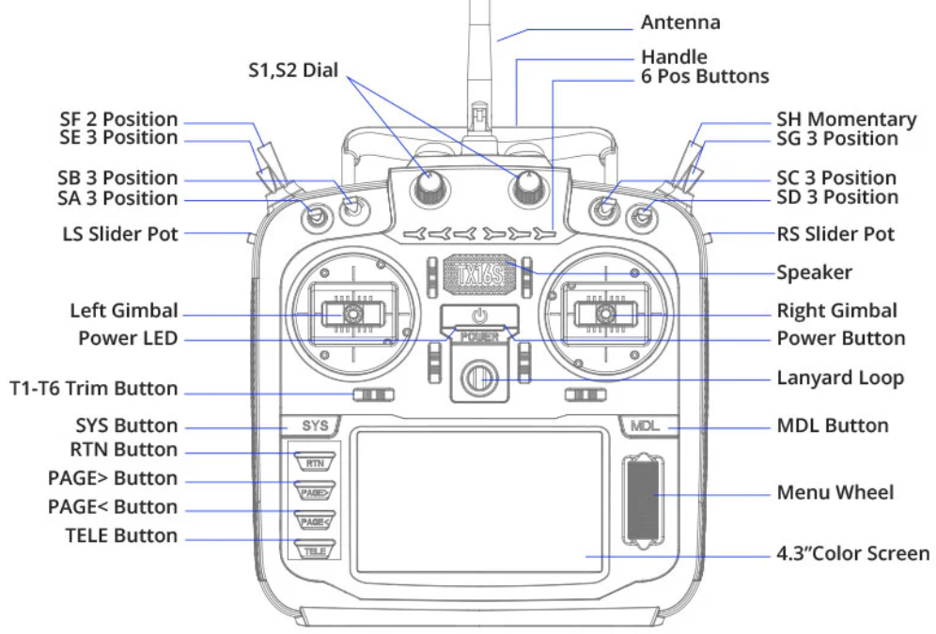
2D Drawing of Transmitter (II)

2.7.2 Control & Navigation System
(I) Pixhawk Cube Orange/+ (Flight Controller)
The flight controller is the drone's brain, processing inputs from the receiver and sensors to stabilize and control the UAV.
We use the Pixhawk Cube Orange/+, a high-performance controller with advanced processing, sensor redundancy, and support for PX4 and ArduPilot. It ensures reliable, precise control for professional UAV applications.
Specification
FMU Processor | STM32H757 (32-bit Arm® Cortex®-M7, 400 MHz, 2MB Flash, 1MB RAM)
IO Processor | STM32F103 (32-bit Arm® Cortex®-M3, 24 MHz, 8KB SRAM)
Sensors | 3x ICM-45686 Accelerometer/Gyroscope (BalancedGyro™ Tech)  Barometers: MS5611  Magnetometer: ICM42688 IMU, ICM20948 IMU  Accel/Gyro: ICM 20649
Max Input Voltage | 4V – 5.7V
Current Limiters | TELEM1: 1.5A  All other ports (combined): 1.5A
Flight Controller Dimensions |  | 38.4mm x 38.4mm x 22mm
Weights | 74g
PWM Outputs | 14
R/C Inputs | CPPM, Spektrum / DSM and S.Bus
GPS Ports | 2 (1 full with safety switch, 1 basic)
I2C Ports | 1
CAN Buses | 2 (with silent or ESC RX-MUX control)
Operating Temperature |  | -40°C to 85°C
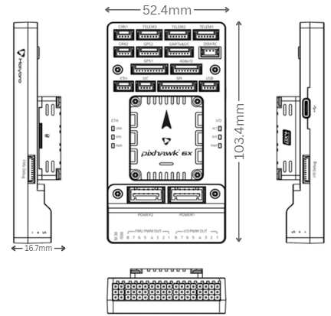
2D Drawing of Pixhawk
(II) CUAV Neo 3 (GPS)
The NEO 3 is a high-accuracy, cost-effective GNSS positioning and navigation module designed for UAVs. It uses the u-blox NEO-M9N GNSS receiver supporting GPS, Beidou, Galileo, and GLONASS concurrently, delivering improved accuracy and strong anti-interference performance. The module integrates a compass, RGB status LED, buzzer, and safety switch, making it a compact, plug-and-play solution for professional and competition UAV builds.
Specification
Sensitivity | Tracking/Nav:-167dBm
GNSS Receiver | u-blox Neo-M9N
Compass | IST8310
Power Consumption | ~0.6 – 0.9 W
Operating Temperature | -10 °C to 70 °C
Dimension | 60 × 60 × 16 mm
Weight | 33 g
2D, 3D Drawing of GPS Module:

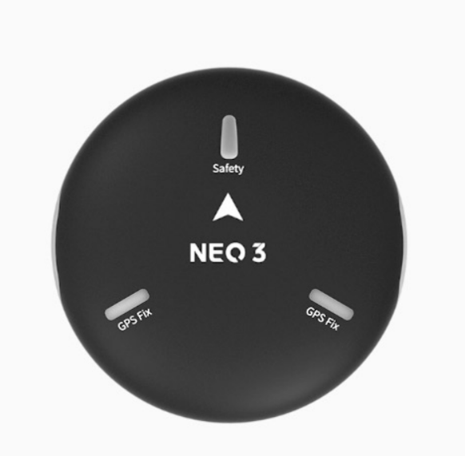
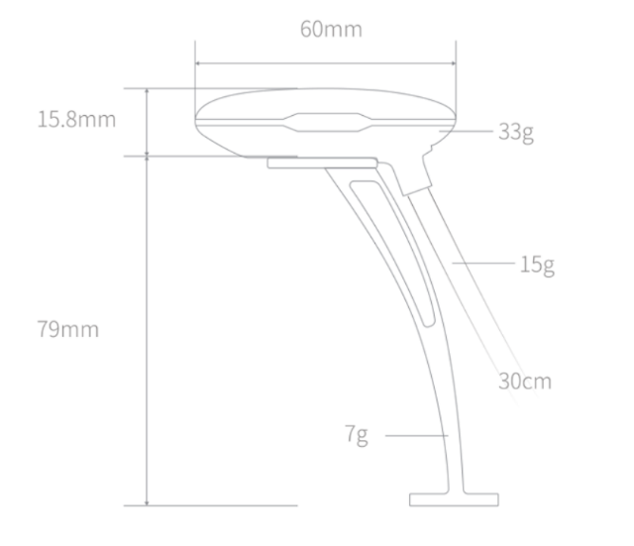

(III) Raspberry Pi 5
Raspberry Pi serves as a companion computer for our multi-rotor UAV, handling AI-based computations such as target recognition.
We are using the Raspberry Pi 5, which processes visual data and communicates results to the Pixhawk Flight Controller via the serial port, enabling advanced autonomous functions.
Specification
Processor | Broadcom BCM2712, Quad-core 64-bit Arm Cortex-A76 @ 2.4GH
Ram | GB LPDDR4X-4267
GPU | VideoCore VII (Supports OpenGL ES 3.1, Dual 4Kp60 HDMI)
Storage | microSD slot (SDR104 support), PCIe 2.0 x1
Power Supply | 5V/5A via USB-C (PD supported)
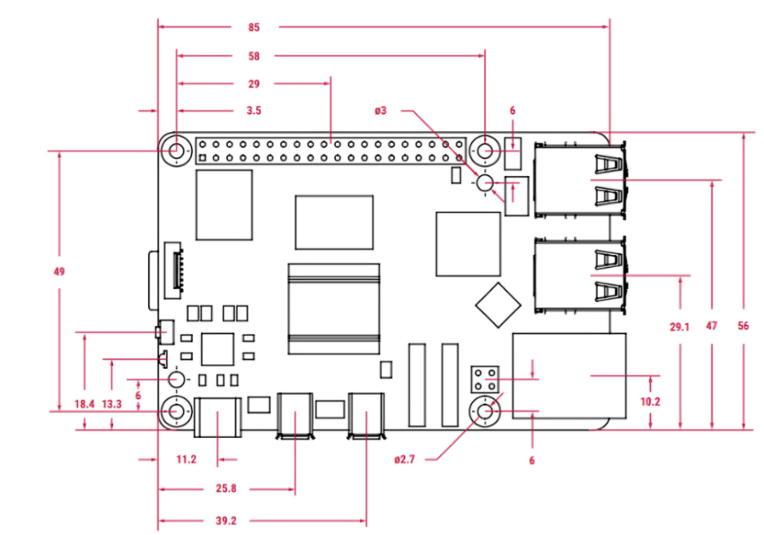
2D Drawing of Raspberry Pi
(IV) RunCam Phoenix 2 SP V3 Cam
An FPV (First-Person View) camera provides real-time video feed from the drone to the pilot, allowing precise manual control and situational awareness during flight.
We are using the RunCam Phoenix 2 SP V3 FPV Camera, which offers excellent image quality, low latency, and strong low-light performance, making it ideal for stable and clear live video transmission in our UAV.
Specification
Sensor | 1/2.8" Starlight COMS Sensor
Lens | FOV D:155° H:122° V:92°/FOV D:138° H:122° V:68°
Aspect Ratio | 4:3 / 16:9 switchable
Power | 5–36V
Weight | 7.5g
Size | 19mm*19mm*20mm
2D Drawing of FPV Camera

(V) Holybro PM06 V2 Power Module
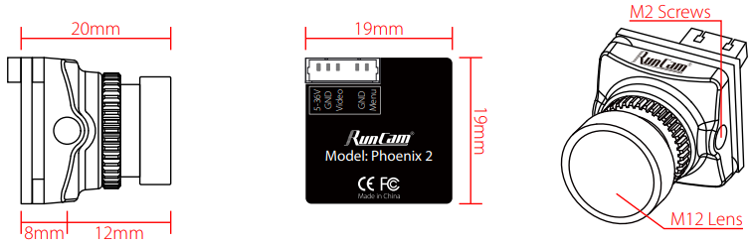
The PM06 Power Module provides a stable 5.2V power supply to the flight controller directly from the main battery while simultaneously measuring battery voltage and current consumption via analog signals. It also includes integrated power distribution for up to 4 ESCs, making wiring cleaner and more reliable.
The module comes pre-soldered with XT60 connector, wires, and capacitor, ensuring easy installation and reduced electrical noise.
Specifications
Battery Voltage Support | 2S–10S (standard) / 2S–14S (HV version)
Current Handling Capacity | 70A continuous, 120A burst
Regulated Power Output | 5.2V @ 3A (18W max)
Power Distribution & Sensing | Integrated 4-ESC distribution with analog voltage & current feedback
Mechanical size | 35×35×5 mm
Weight | 24g

(VI) GEPRC MATEN 5.8G 3W VTX PRO
The MATEN 5.8G 3W VTX PRO by GEPRC is a high-power FPV video transmitter designed for long-range and competition UAV builds. Featuring a dual-core architecture with up to 3000mW output, it delivers strong signal penetration and stable transmission.
Its CNC aluminium alloy housing, combined with an active cooling turbofan and thermal protection, ensures reliable performance under high-load, continuous-flight conditions. With IRC Tramp support, pilots can control VTX settings directly via OSD, making it ideal for professional and competitive FPV setups.
Specifications
Maximum RF Output Power | Up to 3000 mW (25 / 200 / 600 / 1600 / 3000 mW + Pit)
Cooling & Thermal Design | CNC aluminium shell + active micro turbofan + thermal protection
Input Voltage Range | 7–36 V (2S–8S)
Control & Configuration | IRC Tramp protocol (OSD adjustable)
Channel | 80 channels
Frequency Support | 4.9–5.8 GHz

2.7.3 Avionics and sensors
The avionics system handles navigation, stabilization, communication, and data processing. Our drone's setup is chosen for reliability and precision, supporting advanced autonomous features for tasks like surveying.

S. no. | Components | Name
1 | Flight Controller | Pixhawk Orange Cube/+
2 | ESC (Electronic Speed Controller) | Cyclone 45A ESC
3 | Transmitter | Skydroid T10
4 | Power Module | Holybro PM06 V2
5 | GPS | CUAV Neo 3
A sensor in a drone is an electronic component that detects physical changes or conditions in the environment or the drone itself, then sends this data to the flight controller or other systems for processing.
S. no. | Components | Sensors
1 | CUAV Neo 3 | GNSS Receiver  IST8310 Compass
2 | Pixhawk Orange Cube/+ | 3x ICM-45686 Accelerometer/Gyroscope (BalancedGyro™ Tech)  Barometers: MS5611  Magnetometer: ICM42688 IMU, ICM20948 IMU  Accel/Gyro: ICM 20649

2.8 Center of Gravity (C.G.) Estimation & Stability Analysis
The Centre of Gravity (CG) is crucial for UAV stability, ensuring balanced load across motors for better control and maneuverability.
For our UAV, the CG was determined using both CAD-based mass analysis (Fusion 360) and structural simulation software (ANSYS 2025 R1).
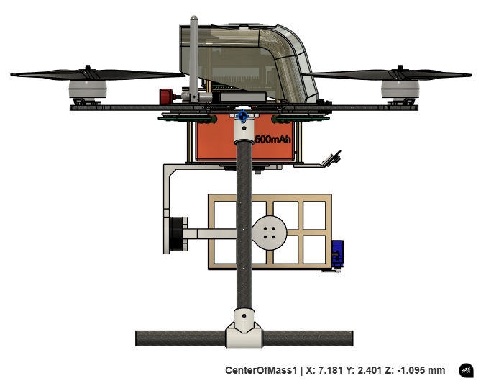
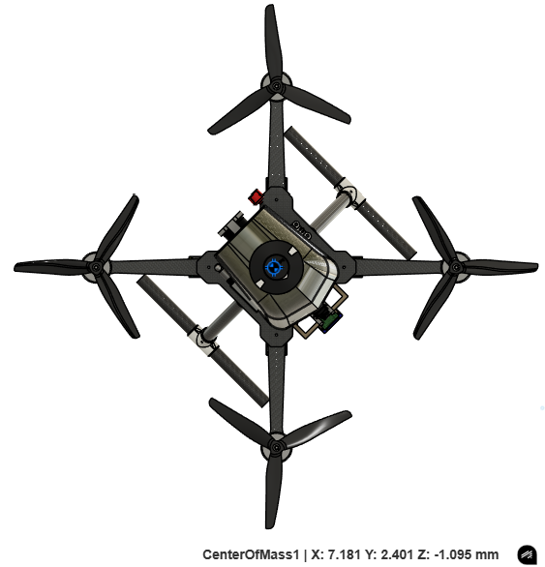
In Fusion 360, CG coordinates were: X = 7.181 mm, Y = 2.401 mm, Z = -1.095 mm

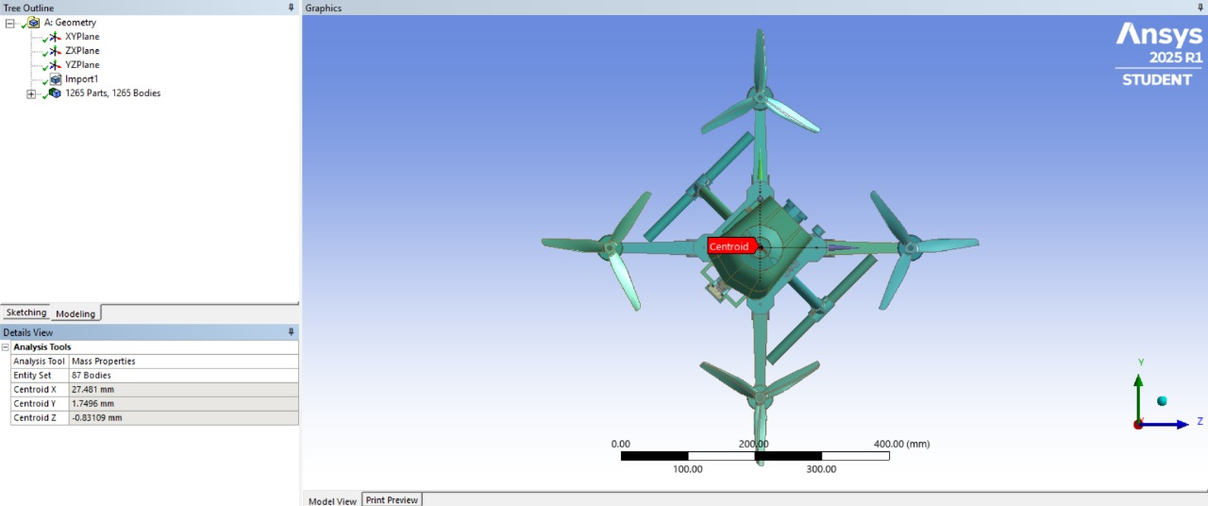
In ANSYS, CG coordinates were: X = 27.481 mm, Y = 1.7496 mm, Z = -0.8311 mm

2.9 Preliminary CAD Model
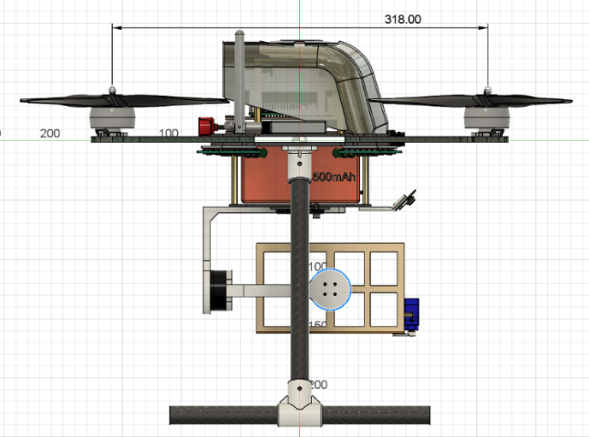
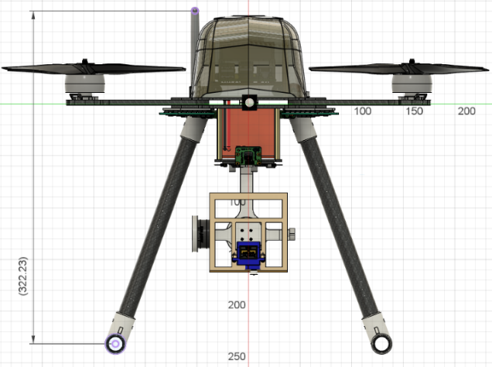
A Preliminary CAD Model of our drone refers to the initial 3D design created using CAD (Computer-Aided Design) software that represents the basic structure and components of the drone before final optimization and detailed engineering.

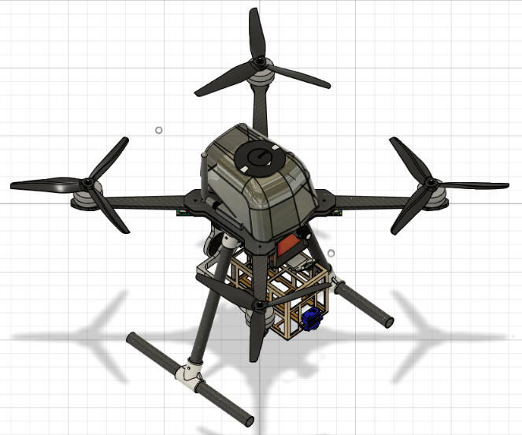
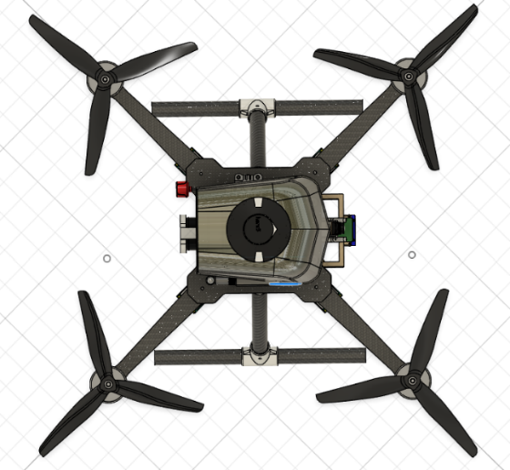
Front View Side View

Top View Angle View

2.10 Computational Analysis
STRUCTURAL ANALYSIS
In the structural analysis, a 60 N thrust force and a 20 N payload are applied to both the frame and the arm.
Total Deformation: Total Deformation is the magnitude of the total displacement of a point in all directions, showing how far that point has moved from its original position.
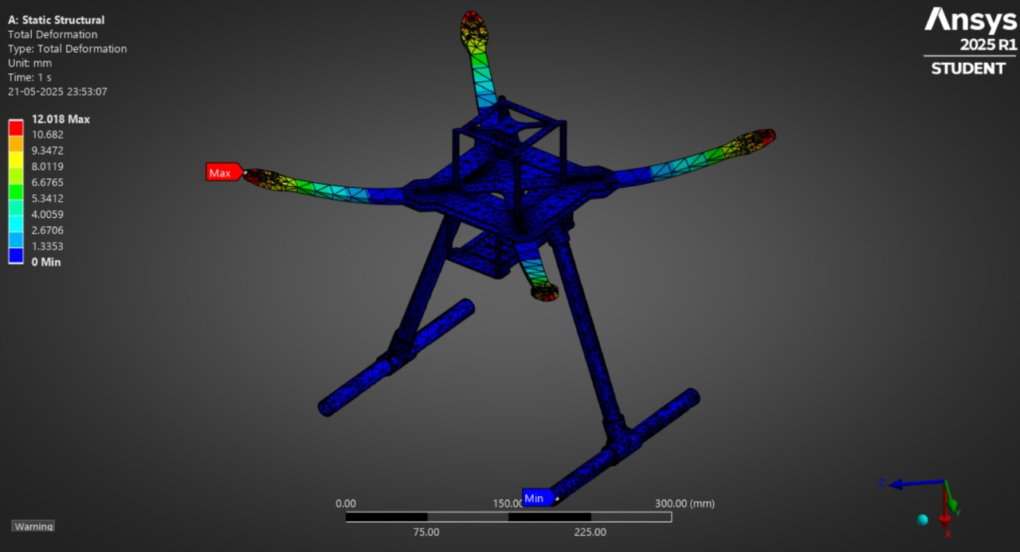
Frame
Maximum Deformation: 12.018
Minimum Deformation: 0 m
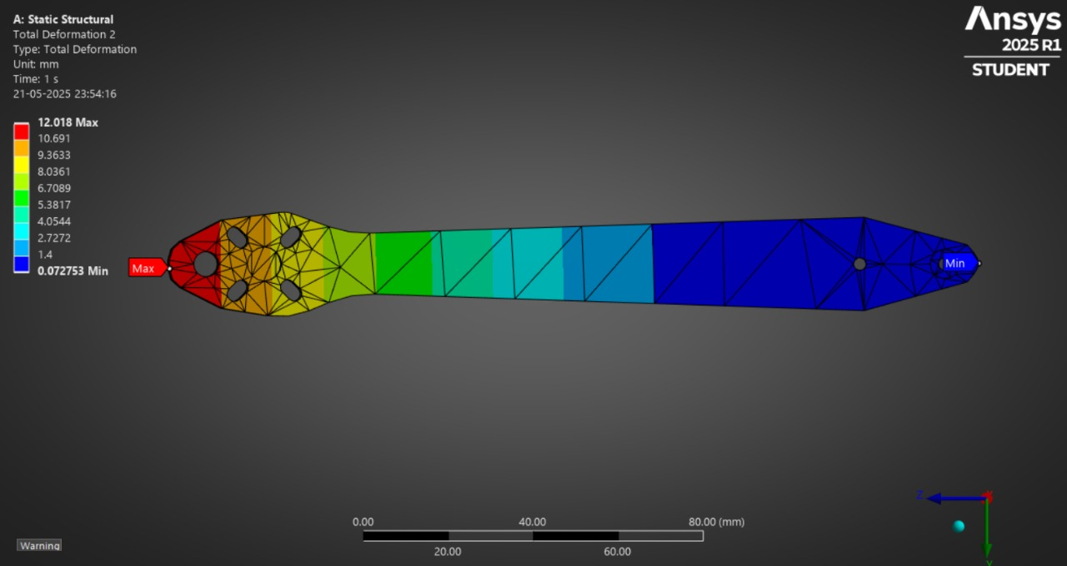
Arms
Maximum Deformation: 12.018 mm
Minimum Deformation: 0 mm
The simulation showed very little deformation in the Frame and Arms, which means the design is structurally strong.
Equivalent Elastic Strain: Equivalent Elastic Strain is the amount of strain energy per unit volume a material stores under elastic deformation, expressed as a single value, typically used for comparing to yield strain limits.
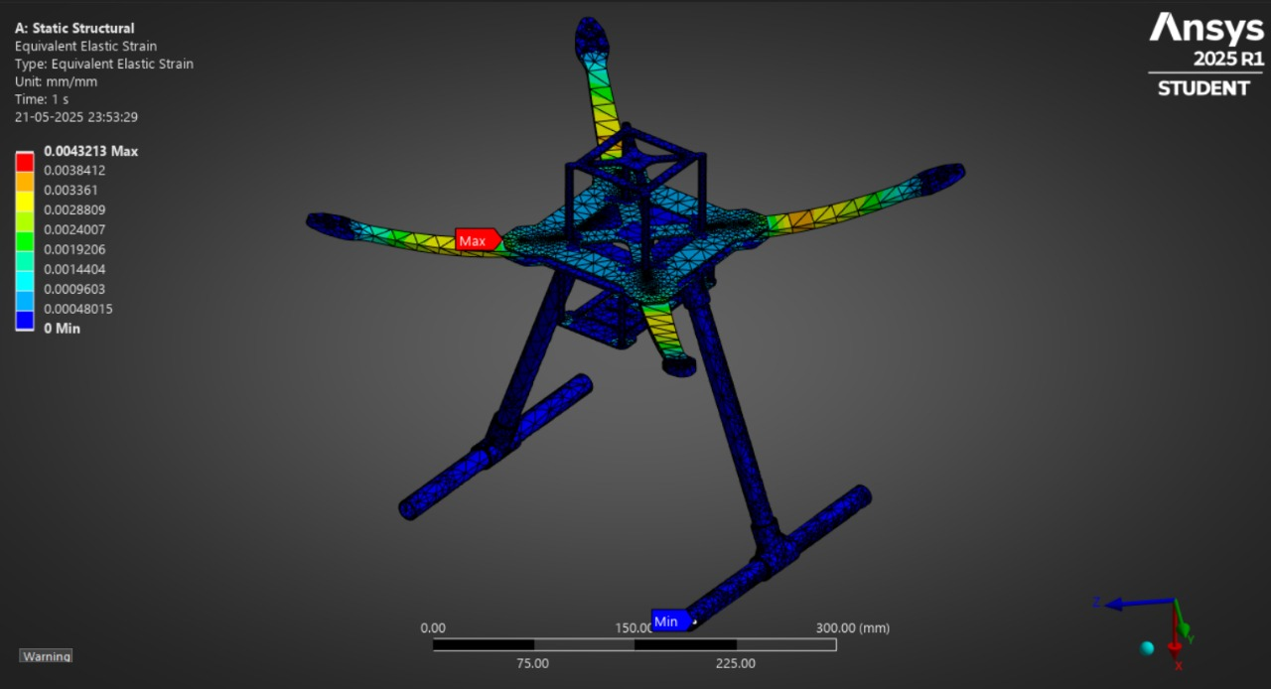
Frame
Maximum Elastic Strain: 0.0043213
Minimum Elastic Strain: 0
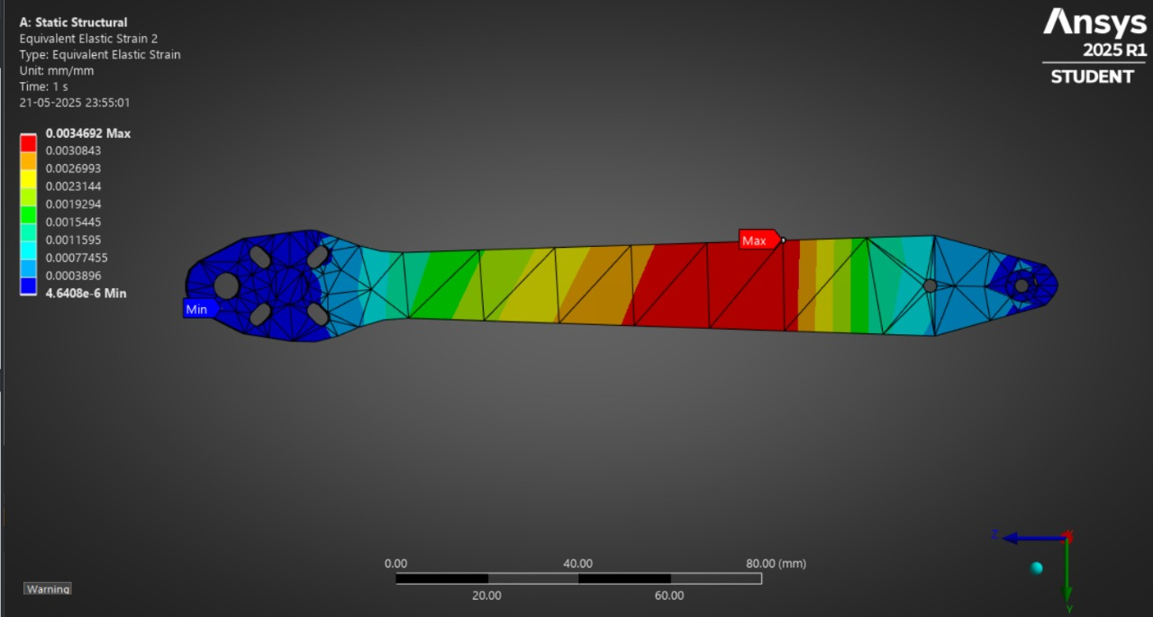
Arms
Maximum Elastic Strain: 0.0034692
Minimum Elastic Strain: 0
The strain values stayed within safe limits, indicating the material only experienced elastic deformation.
Equivalent Stress: Equivalent Stress (also known as von Mises stress) is a calculated value that combines the different normal and shear stress components into one value, making it easier to compare against the material's yield strength
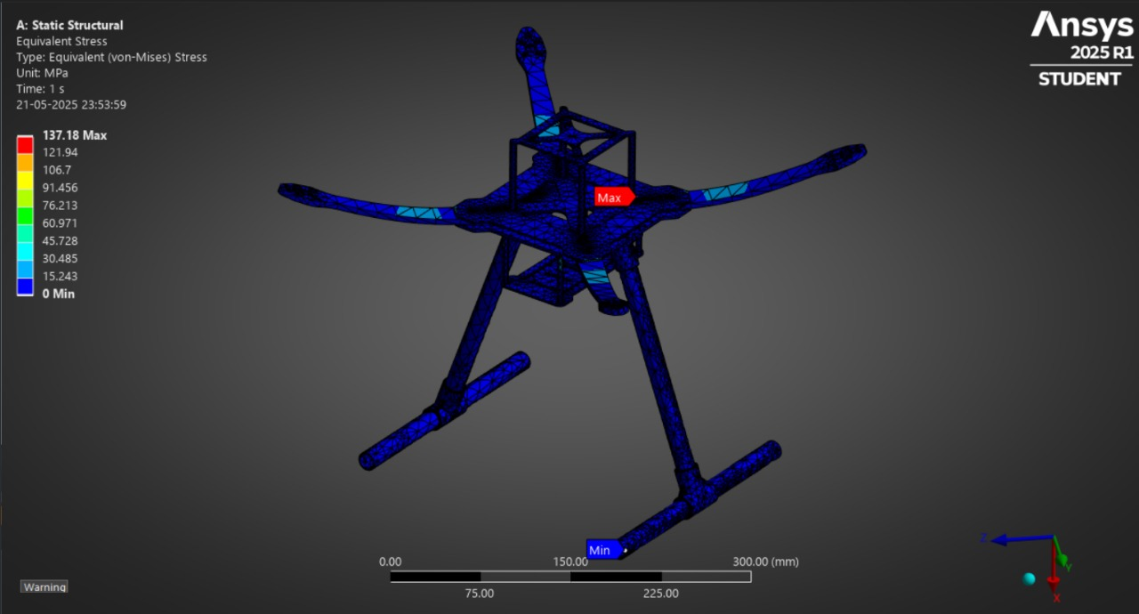
Frame
Maximum Elastic Strain: 137.18 MPa
Minimum Elastic Strain: 0
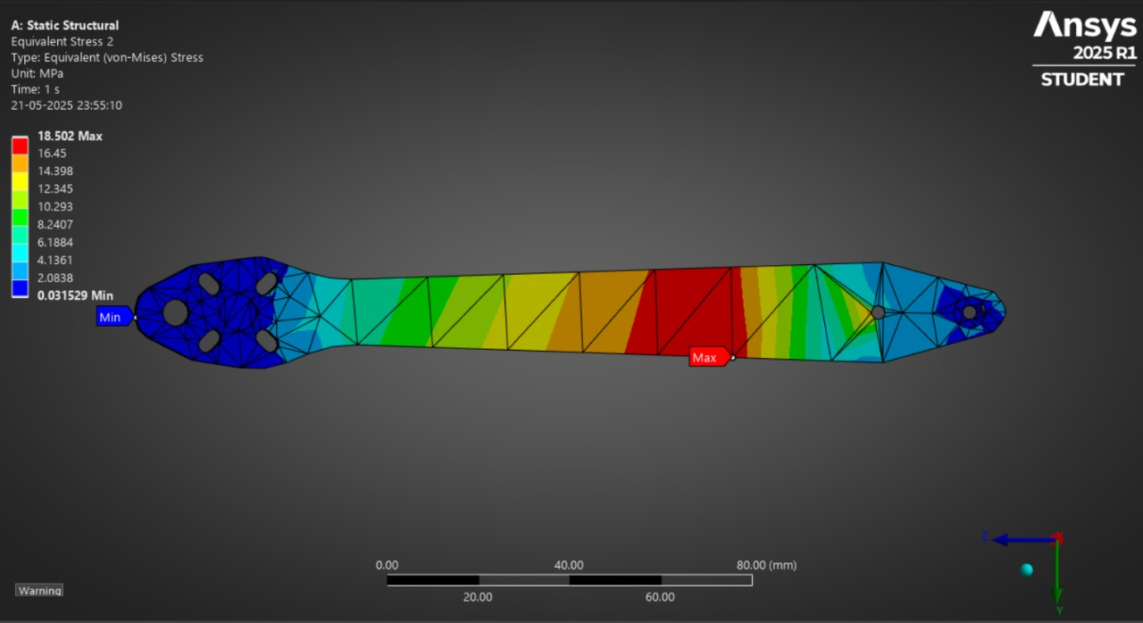
Arms
Maximum Elastic Strain: 18.502 MPa
Minimum Elastic Strain: 0
The stress values were all below the yield strength, confirming that the structure is safe under load.

2.11 Optimized Final Design
During the initial prototype phase, our drone was equipped with ReadytoSky OPTO 40A ESCs and a 5200 mAh 4S LiPo battery, contributing to a total takeoff weight of approximately 2100 g. This weight exceeded the Micro UAV category limit defined in the Aerothon competition rules. In response, we conducted a critical review of the propulsion-related components and implemented targeted optimizations to reduce overall weight without compromising performance.
By replacing the heavier OPTO ESCs with lightweight BLHeli ESCs and switching to a higher-capacity, lower-weight Li-ion battery, we successfully reduced the total UAV weight to ~1905 g, bringing it into the compliant range for Micro UAV classification.

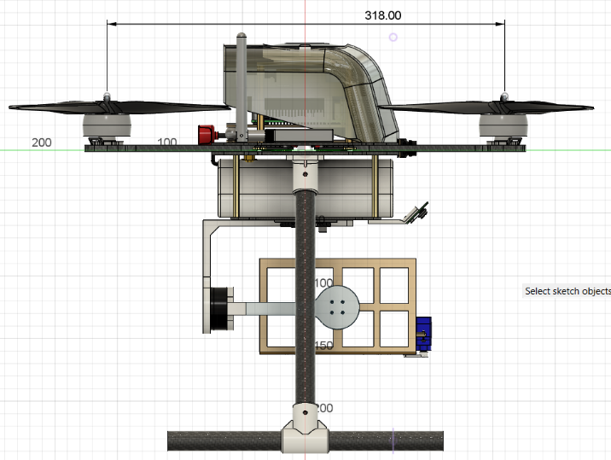
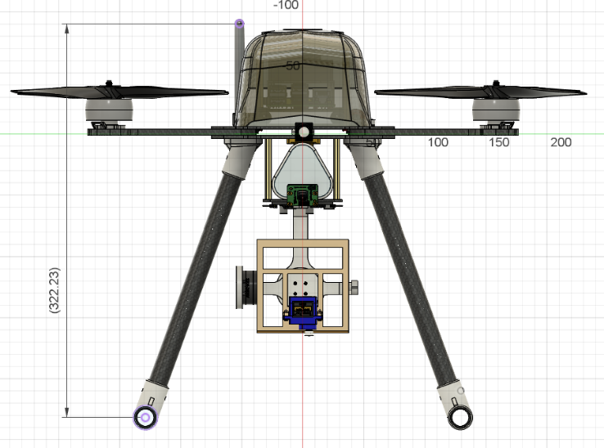
2.11.1 Final CAD model

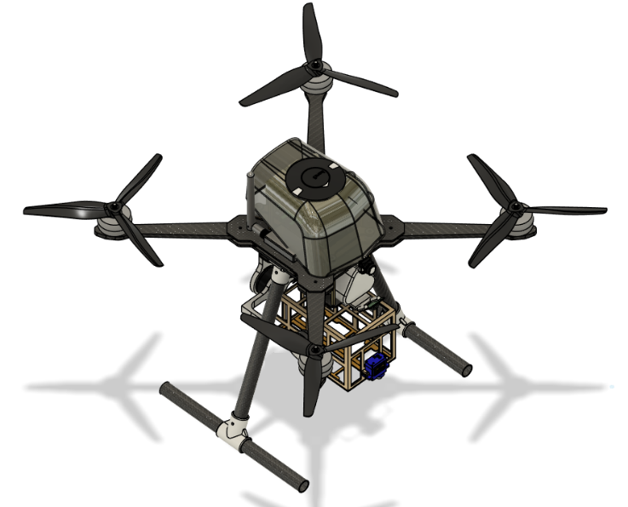
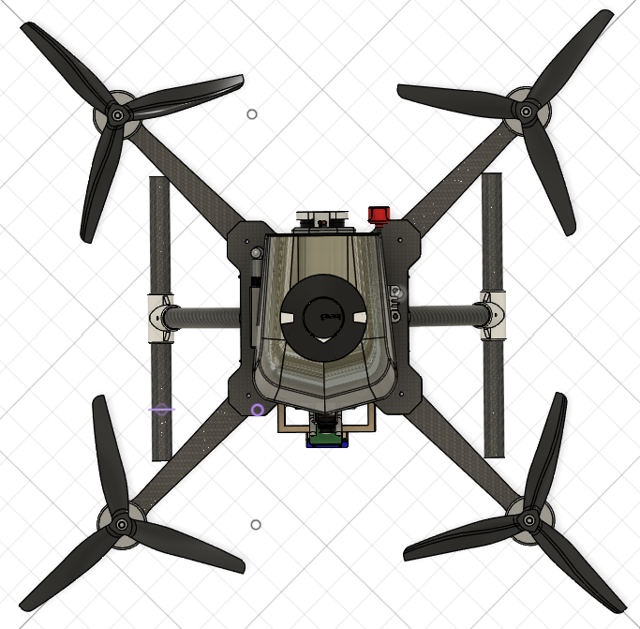
Front View Side View

Top View Angle View

2.11.2 Final 2D drafting
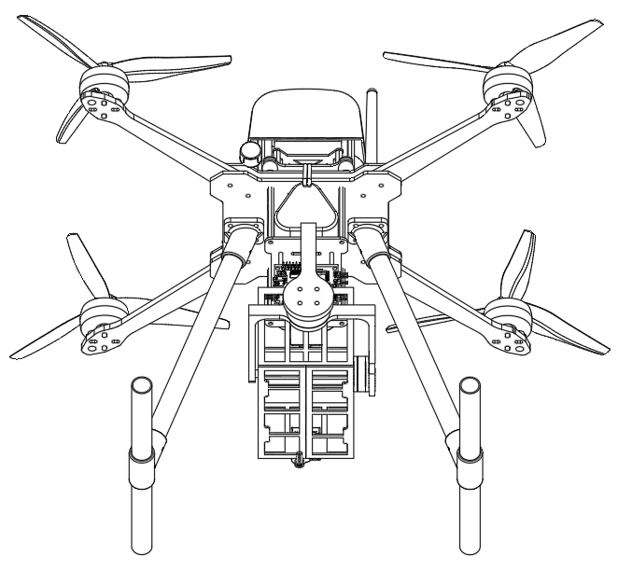
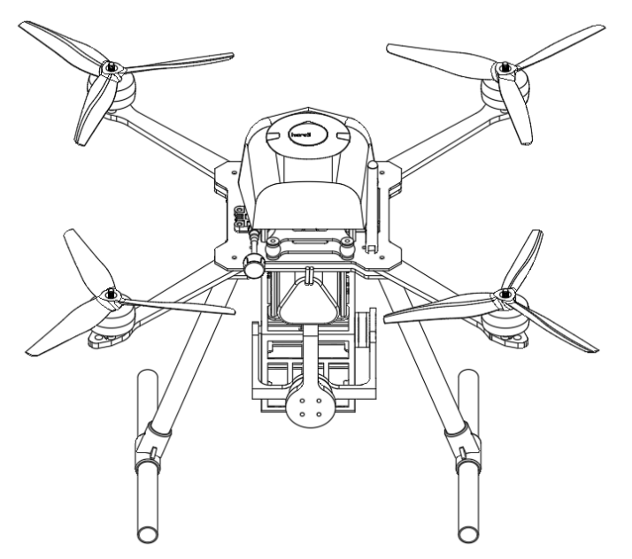

Back View Bottom View
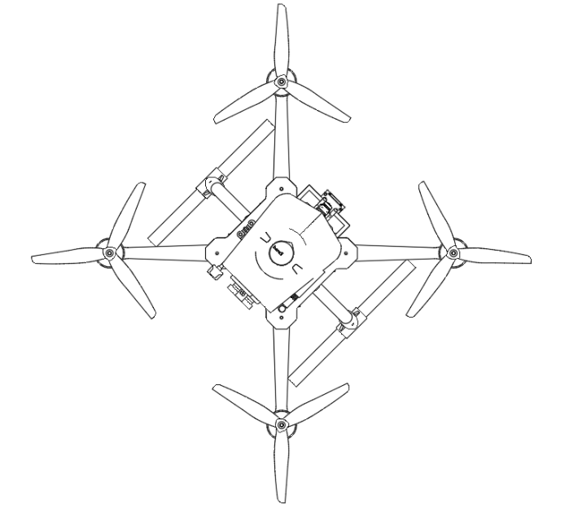
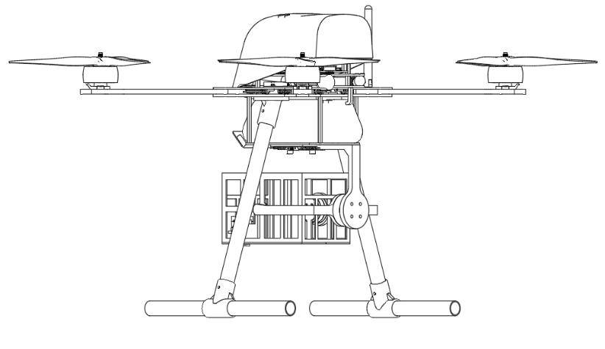

Top View Side View

2.11.3 Updated C.G. analysis
The updated CG was determined using both CAD-based mass analysis (Fusion 360) and structural simulation software (ANSYS 2025 R1).
In Fusion 360, the full assembly, electronic components, frame, and propeller systems was considered for CG calculation.
The computed CG coordinates were: X = 7.181 mm, Y = 2.401 mm, Z = -1.095 mm
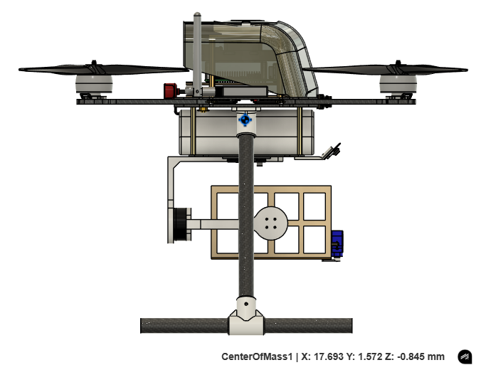
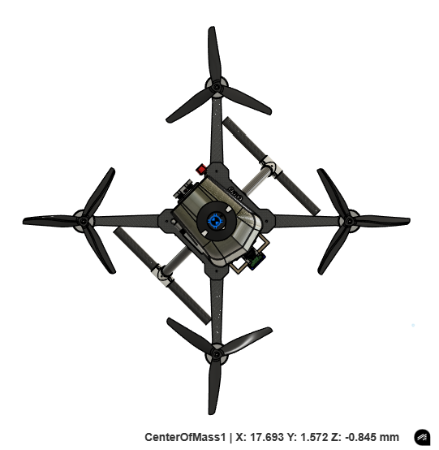

In ANSYS, a static structural analysis was performed considering the mass distribution of the frame structure.
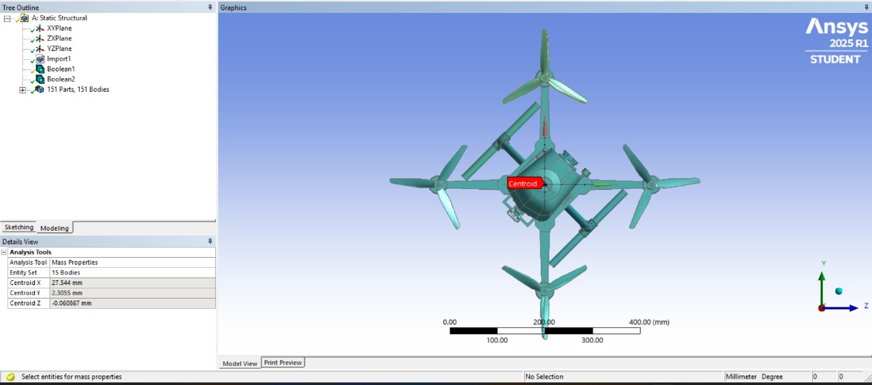
The calculated centroid coordinates were: X = 27.544 mm, Y = 2.3055 mm, Z = -0.0608 mm

2.12 Detailed Weight Breakdown & C.G. Analysis
After upgrading to Cyclone 45A ESCs (6g each) and a 9000mAh 3s Li-ion battery (440g), which is significantly lighter than the previous setup, the overall weight of the drone has been reduced, resulting in improved flight endurance.
Detailed Weight Breakdown
Components | No. of Units | Unit Weight  (in grams) | Total Weight  (in grams)
Flight Controller | 1 | 74 | 74
BLDC Motor | 4 | 80 | 320
Propeller | 4 | 13 | 52
ESC | 4 | 6 | 24
Receiver | 1 | 0.6 | 0.6
Telemetry | 1 | 21 | 21
GPS | 1 | 52 | 52
Flight Computer | 1 | 105 | 105
Camera | 1 | 9 | 9
FPV Camera | 1 | 9 | 9
VTX | 1 | 5.6 | 5.6
VTX Antenna | 1 | 7.8 | 7.8
Gimbal Motor 1 | 1 | 26 | 26
Gimbal Motor 2 | 1 | 40 | 40
Gimbal Controller | 1 | 10 | 10
Servo Motor | 1 | 9 | 9
Battery | 1 | 440 | 440
Frame + Landing Gear | 1 | ~420 | ~420
Gimbal | 1 | ~80 | ~80
Payload | 1 | 200 | 200
 | Total Weight |  | ~1905g

C.G. Analysis
Shown here is the CG location of our UAV, calculated using ANSYS structural analysis.
The calculated centroid coordinates were: X = 27.544 mm, Y = 2.3055 mm, Z = -0.0608 mm

2.12 UAS Performance Recalculation

2.12.1 Thrust-to-weight ratio
The thrust-to-weight ratio (TWR) is a key performance indicator that compares the total thrust generated by the drone’s motors to its overall weight. It determines the drone’s ability to take off, climb, and carry payloads efficiently. A higher TWR indicates better lift, agility, and responsiveness during flight.
In our drone, we have achieved a thrust-to-weight ratio of approximately 3.7:1. This means the total thrust produced by the motors is 3.7 times greater than the drone’s total weight. Such a high ratio ensures excellent flight performance, allowing for quick takeoffs, stable hovering, efficient payload delivery, and reliable operation even in challenging conditions.
Propeller | Thrust | Voltage | Current | Power | TWR
HQ 8*4*3 | ~1800g (Max at this Power) | 12.6V (max) | 40A | ~500W | ~3.7:1

2.12.2 Power requirements for the mission
S. no. | Components | Name | Operating Voltage  (V) | Operating Current (A) | Power Consumption (w)
1 | Flight Controller | Pixhawk 6X V2B | 6 | 1.5 | 9.0
2 | BLDC Motors (x4) | Xing2 3110 900KV | 14.8 | 65.5 | 969.4
3 | ESC | ReadytoSky 40A ESC | - | - | - (included in motor draw)
4 | Receiver | RP2 V2 ELRS | 5 | 0.1 | 0.5
5 | Telemetry | Holybro V3 500mW | 5 | 0.025 | 0.125
6 | GPS | Hex Here 3+ GPS | 5 | 0.15 | 0.75
.7 | Flight Computer | Raspberry Pi 5 8GB | 5 | 3 | 15.0
8 | Camera | Arducam 64MP | 3.3 | 0.3 | 0.99
9 | Gimbal Motor 1 | 2204 260KV BLDC Motor | 14.8 | 0.4 | 5.92
10 | Gimbal Motor 2 | 2805 140KV BLDC Motor | 14.8 | 0.9 | 13.32
11 | Gimbal Controller | BGC 2-axis Controller Board | 14.8 | 1.3 | 19.24
12 | Servo Motor | TowerPro SG90 | 5 | 0.3 | 1.5
13 | FPV Camera | RunCam Phoenix 2 JB | 5 | 0.2 | 1.0
14 | VTX | SpeedyBee TX800 | 12 | 0.38 | 4.56
 |  |  |  | 74.05 A (max) | 1041.3 W (max)
 | Total…………... |  |  | 27A (as shown in Mission Planner) | 399.6 (as shown in mission Planner)

2.12.3 Endurance Calculation
After replacing the ESC and battery with more efficient and higher-capacity ones, our drone can now fly for a longer time, which improves its performance during tasks.
The Estimated calculation for endurance is hereby: -
Endurance (hrs.) = Battery Capacity (Ah) / Current Drawn (A)
According to the power required estimated values, the calculated endurance is: -
Endurance (min.) = (9(Ah) / 27(A)) * 60
Endurance (min.) = 15.5 min

(3) Final UAS Specifications and Bill of Materials (BoM)
Components | Specification/Model | Qty | Unit Cost | Total Cost
Motor | Xing2 3110 BLDC Motor | 4 | 4,400 | 17,600
ESC | Cyclone 45A ESC | 4 | 1100 | 4,400
Flight Controller | Pixhawk 6X V2B | 1 | 35,000 | 35,000
Flight Computer | Raspberry Pi 5 8GB | 1 | 5,500 | 5,500
GPS | Here 3+ GPS Module RTK Support | 1 | 24,500 | 24,500
Transmitter | Radiomaster TX16S | 1 | 23,000 | 23,000
Receiver | Radiomaster RP2 V2 ELRS | 1 | 2,000 | 2,000
Propeller | HQ Prop 8*4*3 | 1 | 300 | 300
Battery | Li-ion Battery 9000 mAh (3S) | 1 | 3,500 | 3,500
Telemetry | Holybro Telemetry V3 500mW | 1 | 6,000 | 6,000
Camera | Arducam 64MP | 1 | 8,500 | 8,500
Servo | Servo SG90 | 1 | 100 | 100
VTX | Speedybee TX800 | 1 | 3,100 | 3,100
FPV Camera | RunCam Phoenix 2 JB | 1 | 3,900 | 3,900
Antenna | Foxeer Lollipop 4 RPSMA | 1 | 2,000 | 2,000
Wi-Fi Adaptor | TP-Link Wi-Fi Adapter | 1 | 1,200 | 1,200
PDB | Power Distribution Board 100A | 1 | 100 | 100
Gimbal Motor 1 | 2204 260KV BLDC Motor | 1 | 800 | 800
Gimbal Motor 2 | 2805 140KV BLDC Motor | 1 | 900 | 900
Controller Board | BGC 2-axis Controller Board | 1 | 1,200 | 1,200
Frame | Carbon Fiber | 1 | 6,500 | 6,500
Total…... |  |  |  | 1,50,100

(4) Methodology for Autonomous Operations

4.1 Detailed Methodology for Implementing Autonomous Flight
Our UAV system integrates a Raspberry Pi 5 as the companion computer, connected with an Arducam 64MP autofocus camera to handle high-resolution image acquisition and onboard computation. The system leverages DroneKit Python scripts to automate flight operations, and communicates with the Pixhawk flight controller using the MAVLink protocol. This architecture allows real-time mission control, telemetry handling, and sensor integration for both surveying and disaster response missions.

4.2 Surveying Method and Autonomous Data Collection
Geofence Integration: Geofence coordinates define the operational boundary of the mission and are uploaded to the drone's flight controller via DroneKit and Mission Planner software. This ensures the UAV remains within designated safety perimeters during autonomous missions.
Zigzag Path Planning: To guarantee complete coverage of the survey area, a zigzag flight pattern is implemented. This path ensures parallel-line traversal that spans the geofenced area, minimizing blind spots and ensuring efficient area mapping.
Camera and Imaging Setup: An Arducam 64MP autofocus camera is mounted downward-facing to capture high-resolution images. Due to vibration concerns, real-time object detection is avoided. Instead, images are taken at consistent intervals and stored for offline processing.
Takeoff and Landing: Both are fully autonomous using pre-configured flight modes, enabling seamless mission execution.

4.3 Techniques for Autonomous Object or Target Identification
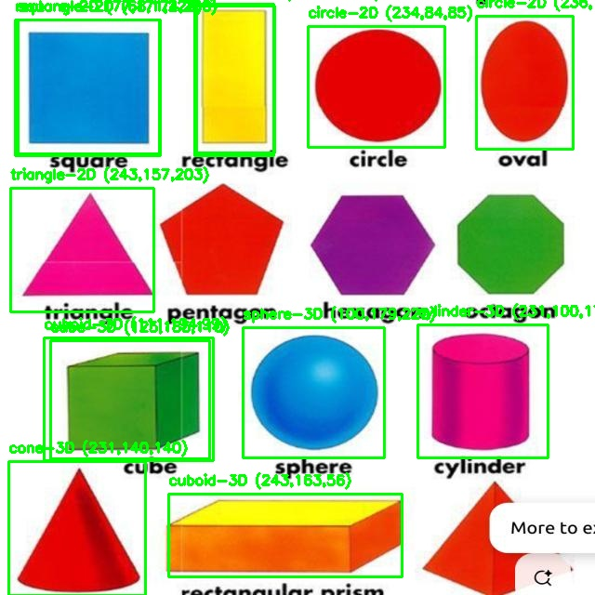
Model Used: A YOLOv8 custom-trained object detection model is deployed to classify detected entities. The model is trained to distinguish between:

• Shape: e.g., circle, square, cone, sphere, etc.
• Dimensionality: 2D (circle, square) vs. 3D (cube, cone, cylinder)
Training Results:
• mAP@0.5: ~0.58
• mAP@0.5:0.95: ~0.36
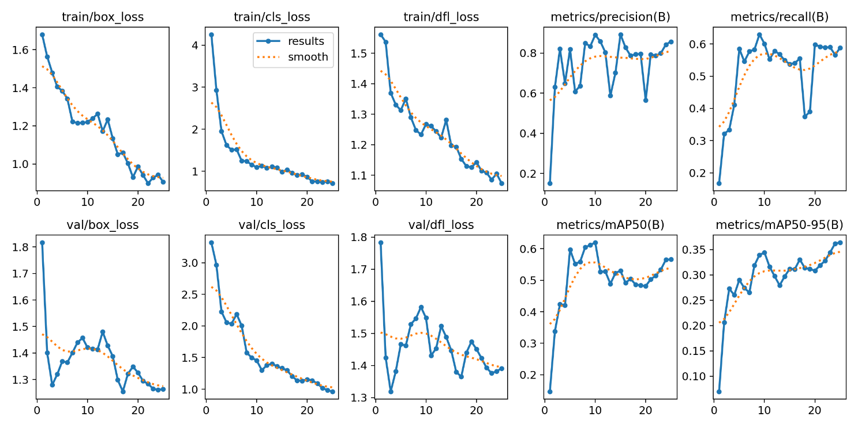
These results reflect moderate detection accuracy, suitable for deployment in semi-structured environments.
Processing Strategy:
• Frame-by-frame images are fed into the YOLOv8 model.
• Detected objects are filtered using confidence thresholds (>80%).
• Duplicate detections are suppressed using spatial clustering and distance thresholds.
Colour Identification:
Using OpenCV HSV filtering, each detected object is classified by colour (e.g., red, blue, green, yellow). Colour plays a key role in verifying object categories during missions.
Geotagging and Counting: Using RTK GPS, each unique object is precisely geolocated. This enables accurate object counts and spatial indexing of detected targets.

4.4 Disaster Management and Response
Disaster Detection Module: To enable disaster zone identification, we deployed a pretrained CNN-based image classification model on Raspberry Pi 5. This model processes live frames from the downward-facing camera and classifies them into categories such as fire, flood, smoke. The CNN was trained on a labeled dataset of aerial disaster imagery and fine-tuned for inference under UAV flight conditions.
High-Confidence Detection and Safe Drop: When the model detects a disaster with high confidence (>80%), the UAV scans for a nearby safe area such as dry land, green zones, or rooftops. Once a safe drop zone is identified, the UAV positions itself above the target using GPS hold delivers the safety equipment using a servo-controlled drop mechanism.
Post-Drop Action: After payload deployment, the drone either resumes its programmed mission path or executes an automatic RTL (Return to Launch).

(5) Summary of Innovations

5.1 Payload box with Gyroscope
In our innovative UAS design, we have developed a gyroscope-stabilized payload-carrying mechanism that ensures controlled and stable delivery of payloads, even under dynamic flight conditions. This system is centered around a gimbal controller, which processes real-time data from an integrated gyroscope sensor embedded within the payload box. The sensor continuously monitors the drone's angular momentum and orientation, allowing the system to detect any instability or tilt during flight or payload release. To actively maintain stability, gimbal motors adjust the orientation of the payload box, ensuring that it remains level throughout the flight and that the payload is released from an optimized, stable position. This approach effectively minimizes the risk of swinging, drifting, or damage to sensitive items during delivery.
Benefits of the Innovation
(I) Enhanced Stability:
The gyroscope-controlled stabilization significantly reduces unwanted rotations and compensates for drone movement, ensuring a smooth and stable drop. This minimizes the risk of damage to sensitive or fragile payloads.
(II) Versatility:
The system is adaptable to a wide range of payload types and delivery scenarios, making it suitable for diverse applications such as humanitarian aid, emergency relief, and commercial drone deliveries.
(II) Improved Accuracy:
Real-time orientation control allows the payload to be released from an optimal position, enhancing drop precision even in unstable or windy conditions.
(IV) Modular Design:
The payload box and gimbal mechanism are designed to be modular and customizable, allowing for easy integration with different drone platforms and mission-specific requirements.
(V) Real-Time Response:
The gimbal controller processes gyroscope data in real time, enabling immediate adjustments during flight for improved performance during dynamic operations.
(VI) Increased Safety:
Controlled and stable payload release reduces swinging and accidental drops, enhancing safety for both the payload and surrounding environment.
Key Components
S. no. | Components | Description
1 | Gimbal Motor 1 | 2204 260KV BLDC Motor
2 | Gimbal Motor 1 | 2805 140KV BLDC Motor
3 | Gimbal Controller | BGC 2-axis Controller Board
4 | Servo Motor | TowerPro SG90
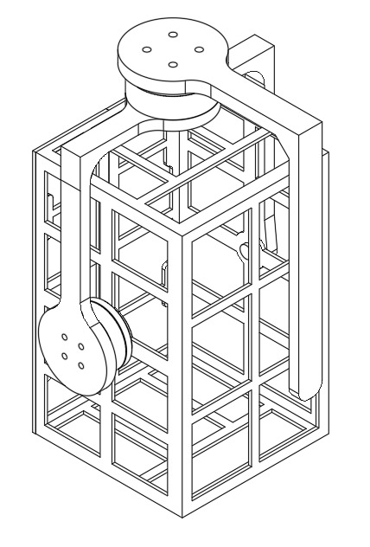
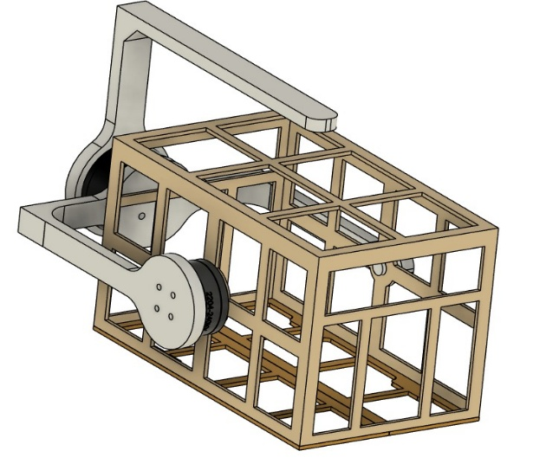
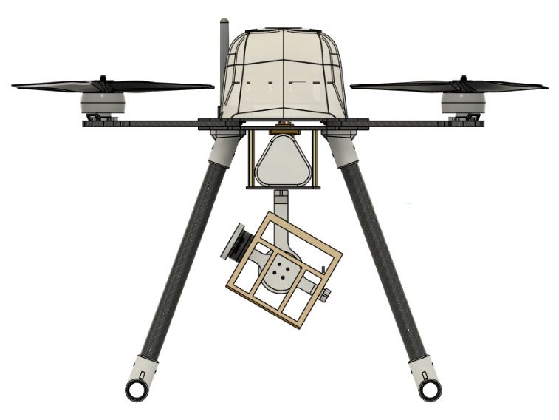
2D and 3D Drawing of Payload box with Gyroscope
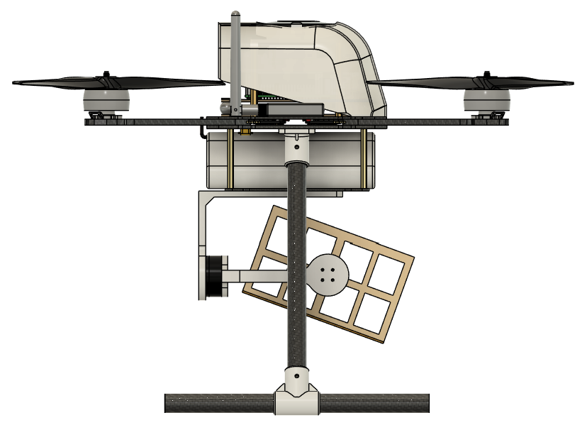

Front View Side View

(6) References

1. Dhwanil Shukla, Narayanan Komerath, "Multirotor Drone Aerodynamic Interaction Investigation".
2. Mingfeng Wang, José-Alfredo Leal-Naranjo, Marco Ceccarelli, Simon Blackmore, "A Novel Two-Degree-of-Freedom Gimbal for Dynamic Laser Weeding: Design,Analysis, and Experimentation," IEEE.
3. Shriharsha S. Veni, Ananda S. Hiremath, Mahalakshmi Patil, Mayuri Shinde, Aishwarya Teli, "Video-Based Detection, Counting and Classification of Vehicles Using OpenCV," ICICNIS 2020, 8 pages, posted January 20, 2021. Written January 19, 2021.
4. Aditya Amoriya, Chandan Kumar, Savita Kumari, "Counting Number of Objects in Images Using Machine Learning," IEEE.
5. Chaoyu Lin, Yuliang Tang, "Research and design of the intelligent surveillance system based on DirectShow and OpenCV," IEEE.
6. http://rcbenchmark.com/
7. Yun Li, Kiam Heong Ang, G.C.Y. Chong, "PID control system analysis and design," IEEE.
8. Daniel Farbman, Chris McCoy, "Materials Testing of 3D Printed ABS and PLA Samples to Guide Mechanical Design".
9. Zahid Ali Siddiqui, Unsang Park, "A Drone Based Transmission Line Components Inspection System with Deep Learning Technique".
10. Giuseppe Silano, Pasquale Oppido, Luigi Iannelli, "Software-in-the-loop Simulation for Improving Flight Control System Design: A Quadrotor Case Study," IEEE.
11. Enrica Soria, Fabrizio Schiano, Dario Floreano, "SwarmLab: A Matlab Drone Swarm Simulator," IEEE.

